**API specification——homework4**

members：窦锦涛 ID:16301085

厉欣林 ID:16301096

our group using ContentProvider and SQLite api to finish the homework4.

# Package dependency:

ContentProiver:

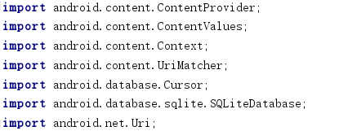

SQLite:



# Implement:

ContentProiver:

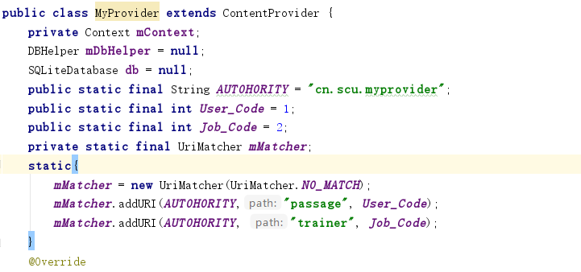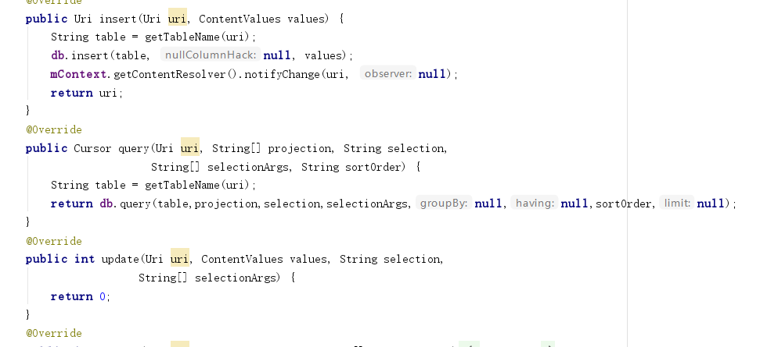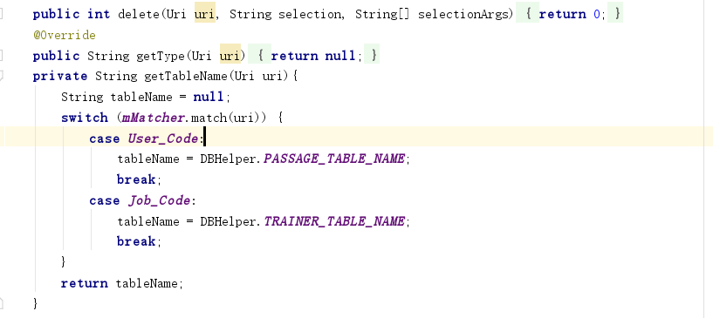

SQLite:

DBhelper:

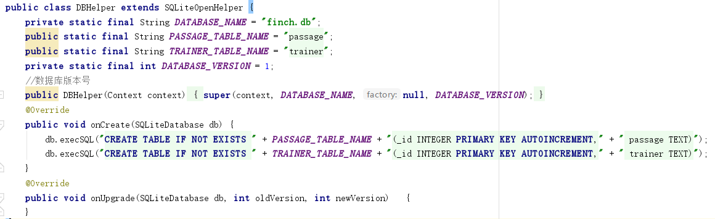

Read into app:

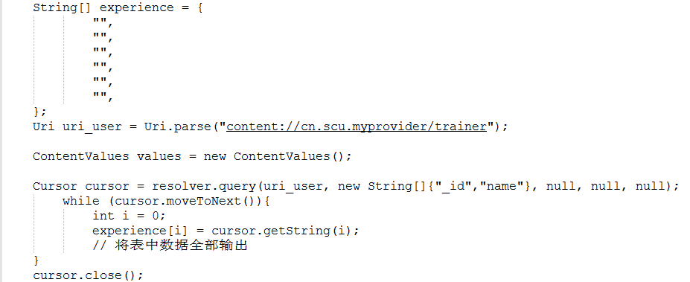

Write into database:

